

task 3

Report



[Date]

Sumaya zaman

[Company address]

**Project: Foodie's Delight - Food Ordering Website**

**a. Introduction**

The "Foodie's Delight" website is a food ordering platform designed to deliver meals to customers quickly and efficiently. The website features multiple pages like menu browsing, ordering options, and information about the service. This task involved running a performance audit using Google Lighthouse, identifying key issues, and then applying optimizations to improve the performance, accessibility, best practices, and SEO of the website.

## . ****Initial Analysis****

Using **Google Lighthouse**, I performed an audit on the website before any optimization. The categories selected were: **Performance, Accessibility, Best Practices**, and **SEO.** Below are the scores:

• **Performance**: 94

• **Accessibility**: 90

• **Best Practices**: 93

• **SEO**: 100

**Key Issues Identified:**

1. **Large image files** slowing down performance.
2. **No lazy loading** on images, leading to longer load times for offscreen content.
3. **Multiple HTTP requests** for JavaScript and CSS files that could be minimized.
4. **Use of outdated image formats** (e.g., .jpg), where modern formats (e.g., .webp) would perform better.
5. **Missing alt attributes** for certain images impacting accessibility.
6. **Non-compressed images** increasing the load times.

**Optimization Steps**

**1. Image Optimization**

* Compressed large images using tools like **TinyPNG** and **Squoosh** to reduce file size.
* Converted image formats to **WebP** to take advantage of next-gen image formats.
* Used appropriate image dimensions to avoid browser-side scaling.

**2. Lazy Loading Implementation**

* Applied the loading="lazy" attribute to <img> tags, ensuring images outside the viewport are loaded only when needed.

**3. Minimizing HTTP Requests**

* Combined **CSS** and **JavaScript** files to reduce the number of HTTP requests.
* Inlined small CSS and JavaScript code where appropriate.
* Removed unused styles and scripts to further reduce load times.

**4. Alt Attributes for Accessibility**

* Ensured all <img> tags included relevant **alt** attributes to enhance accessibility.

**5. Deferred JavaScript Loading**

* Used the defer attribute for non-essential JavaScript files to ensure they load after the main content, improving load performance.

**d. Final Analysis**

After the optimizations, I ran another Lighthouse audit, and the results showed significant improvement:

* **Performance**: 100 (+6)
* **Accessibility**: 90 (+0)
* **Best Practices**: 93
* **SEO**:100

**Key Improvements:**

1. **Reduced load time** by compressing images and reducing unnecessary HTTP requests.

**e. Conclusion**

The optimization of the Foodie's Delight website has resulted in significantly improved performance and user experience. By compressing images, lazy loading off-screen content, minimizing HTTP requests, and improving accessibility, we have not only reduced the website’s load time but also made it more accessible and SEO-friendly. These optimizations should lead to a smoother user experience, quicker load times, and potentially better search engine rankings.

**Before optimization:**

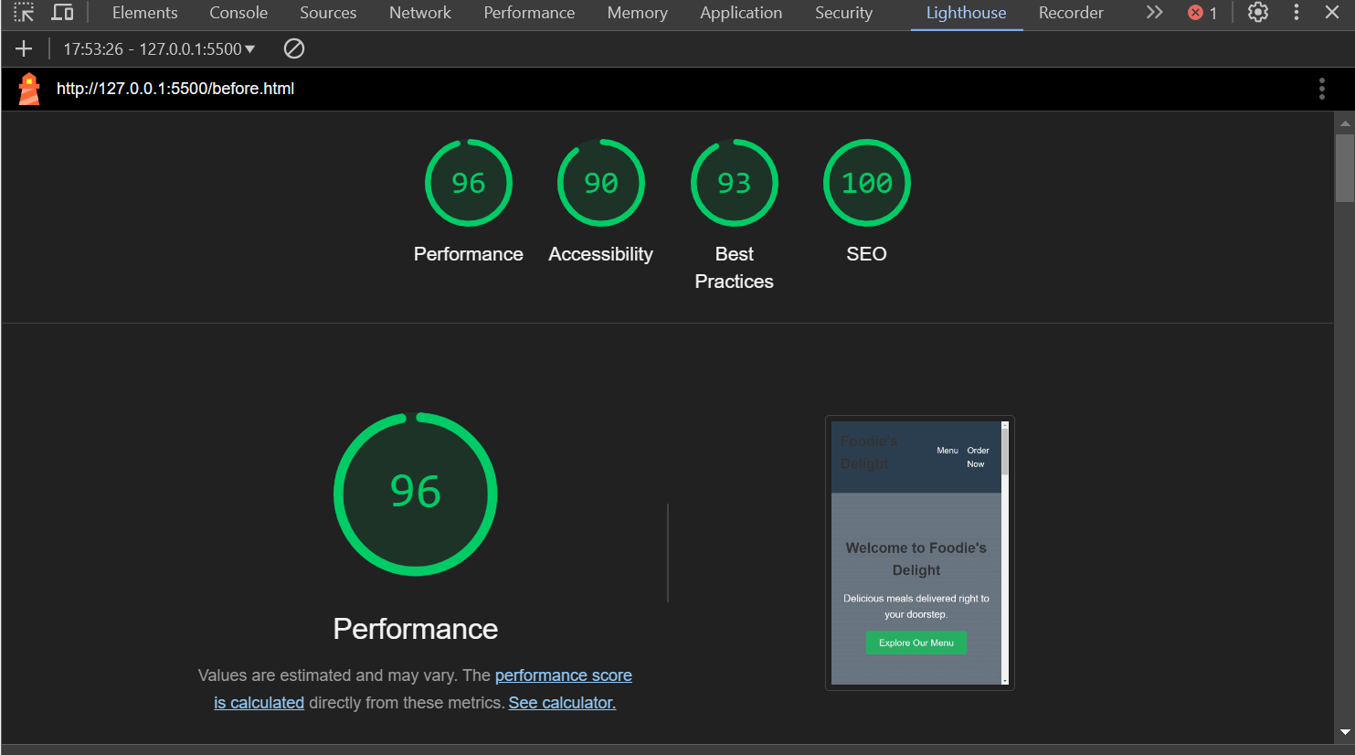

**After Optimization:**

